# Computational Fluid Dynamics Lab

Ryan Dalby

March 18, 2021





**Figure 1b.** Convergence plots from the numerical simulation for an angle of attack of 12o. (left) Residuals of the velocities, continuity equation, and turbulence quantities as a function of iteration number. (middle) Value of the drag coefficient as a function of iteration number. (right) Value of the lift coefficient as a function of iteration number.

**Figure 1a.** Computational mesh used in the numerical simulation of flow over a NACA 0012 airfoil at an angle of attack of 0o and a chord Reynolds number of =1.5x105. (top) Entire domain. (bottom) Enlarged region near the airfoil.



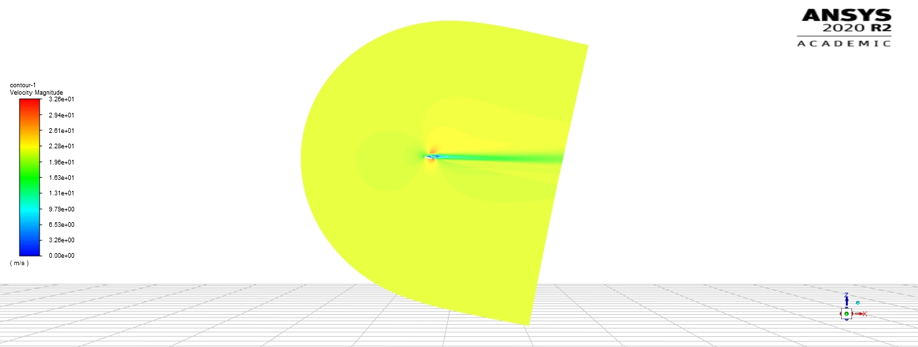

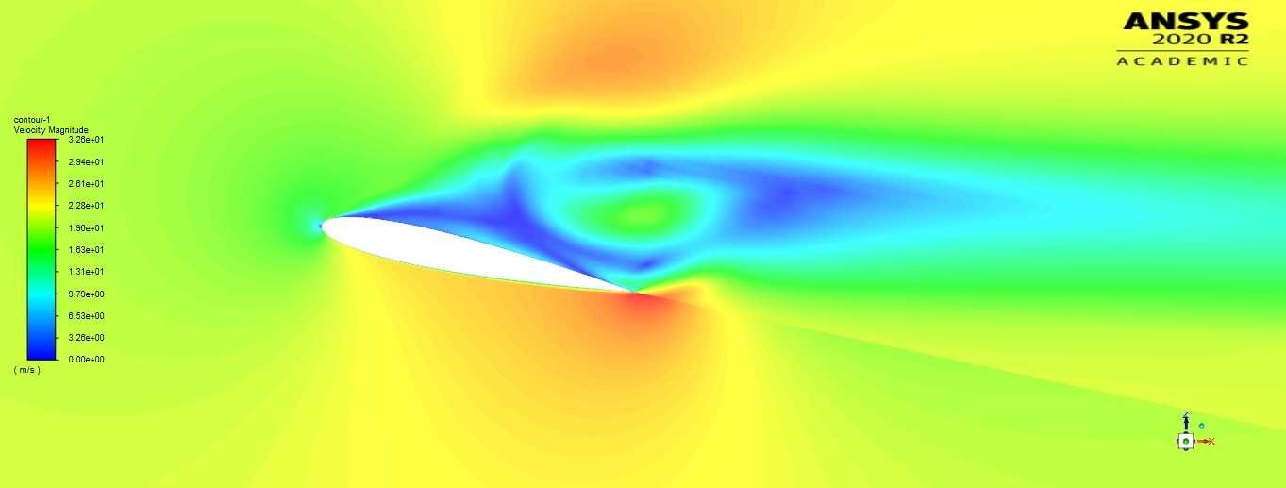

**Figure 1d.** Pathline plot of the flow in the immediate vicinity of the airfoil for an angle of attack of 12o.

**Figure 1c.** Velocity contour plots from the numerical simulation for an angle of attack of 12o. The colorbar indicates velocity magnitude in m/s. (top) Entire domain. (bottom) Enlarged region near near the airfoil.

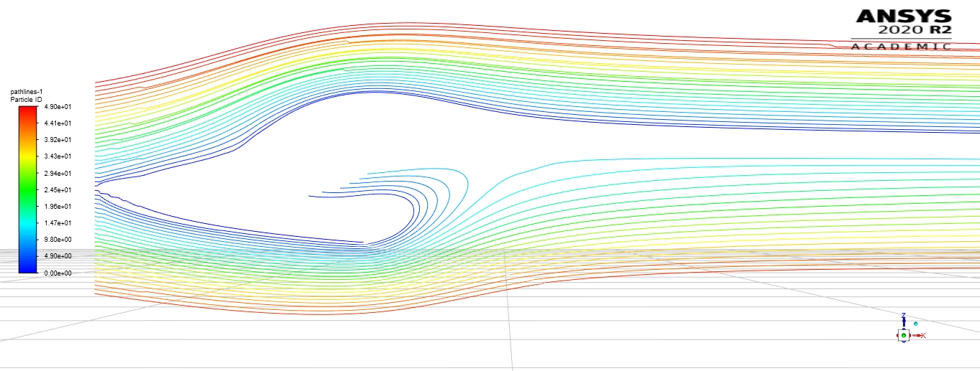

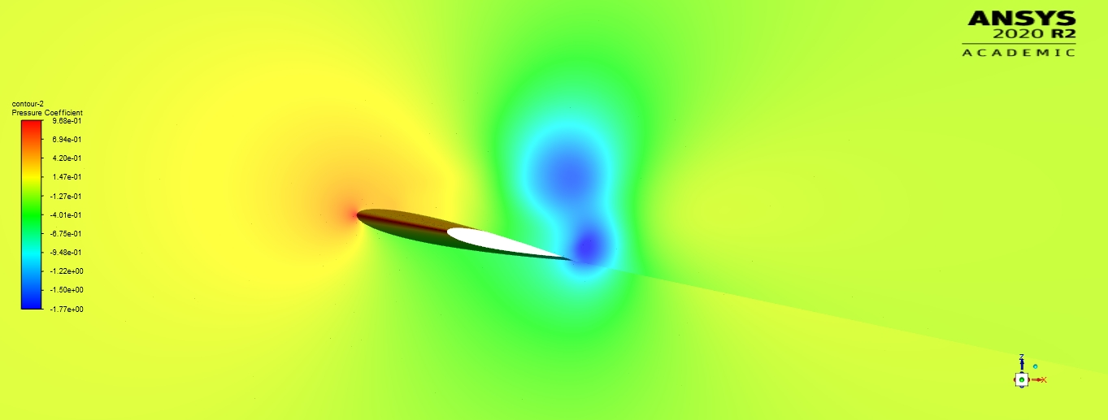

**Figure 1e.** Pressure contour plot in the immediate vicinity of the airfoil for an angle of attack of 12o. The colorbar indicates pressure in Pa.

**Figure 1f.** Output from ANSYS-FLUENT simulations for =1.5x105 plotted with experimental experiment data for coefficients of drag and lift and various Rec values. The MATLAB code to create these plots is attached in the appendix. (left) Coefficent of drag plot. (right) Coefficent of lift plot.

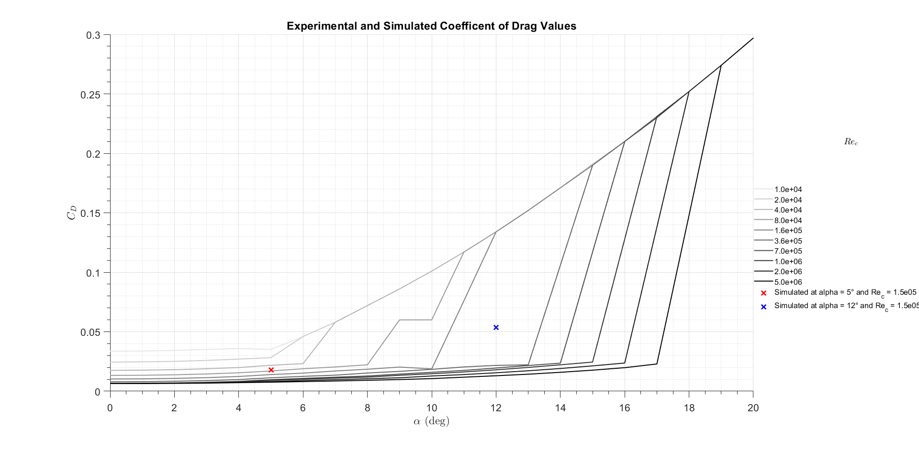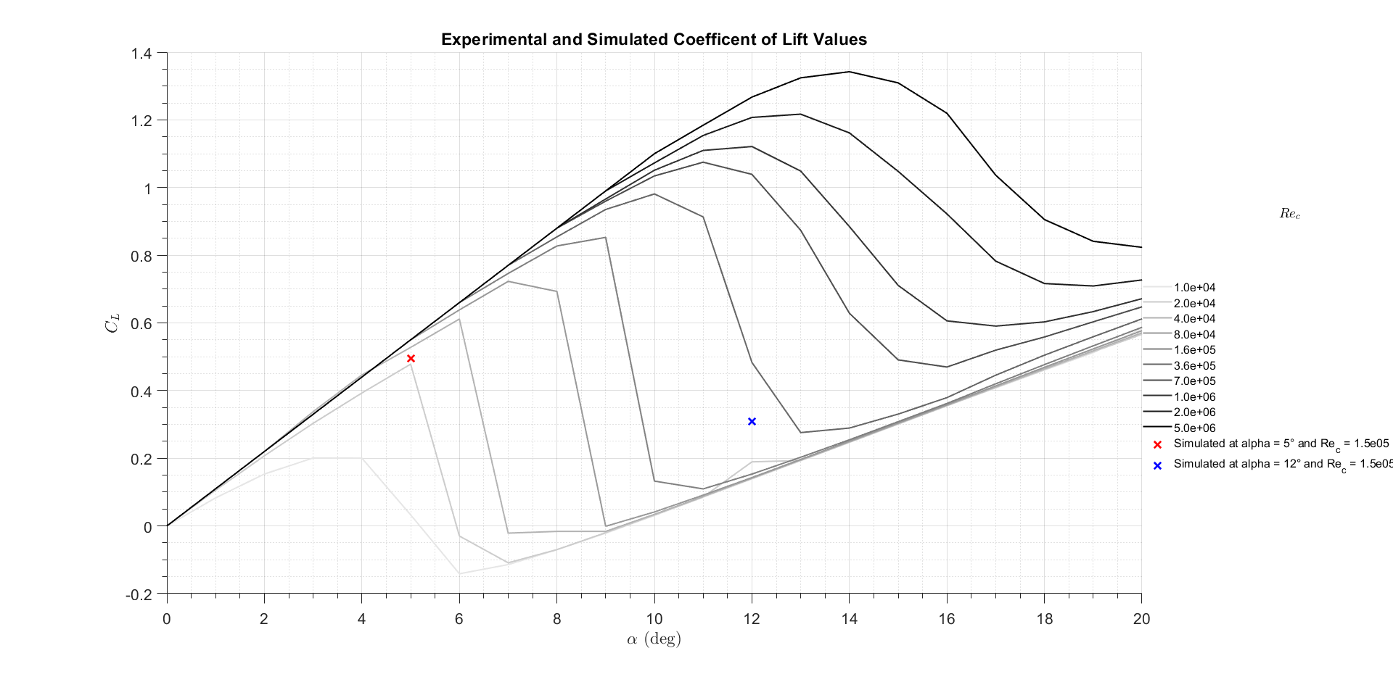

|  |  |  |  |  |  |  |
| --- | --- | --- | --- | --- | --- | --- |
| a (deg) |  | | |  | | |
| Simulation | Experiment | e (%) | Simulation | Experiment | e (%) |
| 5 | 0.01785 | 0.0113 | 25.50 | 0.4961 | 0.55 | 10.86 |
| 12 | 0.05359 | 0.134 | 150.05 | 0.3097 | 0.1533 | 50.50 |

**Table 1g.** Table comparing the lift and drag coefficients from the numerical simulation with those obtained from experimental data.

**2a.**

For the n=50 mesh simulation with a 10 degree angle of attack the solver resulted in coefficient of drag values of 0.355 and coefficient of lift values of 0.861. Comparing to the experimental values in Figure 1f. the coefficient of drag would be should be approximately 0.02 and the coefficient of lift should be approximately 0.1. The associated percent errors are 1675 % and 88.4 % respectively. These percent errors are much higher than even the 12 degree angle of attack with a mesh of n=400 as shown in Table 1g. Thus a higher mesh density results in a more accurate calculation for this lab when comparing mesh densities of n=400 and n=50.

**2b.**

It is necessary to validate any numerical simulation result and this includes computation fluid dynamics results (CFD). This is because the simulation often does not capture important effects of the flow and may not have a fine enough mesh that the solver converges to the real flow valves. For the steady-state solver used for this lab some neglected effects were the transient and turbulent effects. These effects especially make a difference for higher angles of attach as seen in Figure 1f. and Table 1g. which show much larger errors between the simulated values and the experimental values for the higher angles of attack. These differences can also be attributed the inability of the solver to attain continuity convergance as well as steady convergance for all residuals (oscillations can be seen for the residuals) for the 12 degree angle of attack case as shown in Figure 1b.

**Appendix- Plotting code for Figure 1f.**

%% ME EN 4650 Lab6:CFD Ryan Dalby

% 1f

close all;

% CD

openfig('NACA0012_CD.fig');

hold on;

plot(5, 0.01785, 'rx', 'DisplayName', 'Simulated at alpha = 5° and Re_c = 1.5e05', 'MarkerSize', 10, 'LineWidth', 2);

hold on;

plot(12, 0.05359, 'bx', 'DisplayName', 'Simulated at alpha = 12° and Re_c = 1.5e05', 'MarkerSize', 10, 'LineWidth', 2);

title('Experimental and Simulated Coefficent of Drag Values');

openfig('NACA0012_CL.fig');

hold on;

plot(5, 0.4961, 'rx', 'DisplayName', 'Simulated at alpha = 5° and Re_c = 1.5e05', 'MarkerSize', 10, 'LineWidth', 2);

hold on;

plot(12, 0.3097, 'bx', 'DisplayName', 'Simulated at alpha = 12° and Re_c = 1.5e05', 'MarkerSize', 10, 'LineWidth', 2);

title('Experimental and Simulated Coefficent of Lift Values');